**SMART TRAFFIC MANAGEMENT**

Over the years, there has been a sudden increase in the number of vehicles on the road. Traffic congestion is a growing problem everyone faces in their daily life. Manual control of trac by traffic police has not proved to be efficient. Also, the predefined set time for the signal at all circumstances (low and high traffic density) has not solved this problem. A model to effectively solve the above-mentioned problems by using Internet of Things (IoT) is proposed. Smart Traffic management provide an organized, integrated approach to minimize the congestion and   improving safety on city streets through connected technology

**COMPONENTS REQUIRED:**

* ARDUINO UNO
* TRAFFIC SENSOR
* JUMPER WIRES
* BREAD BOARD
* LED

**CIRCUIT DIAGRAM:**

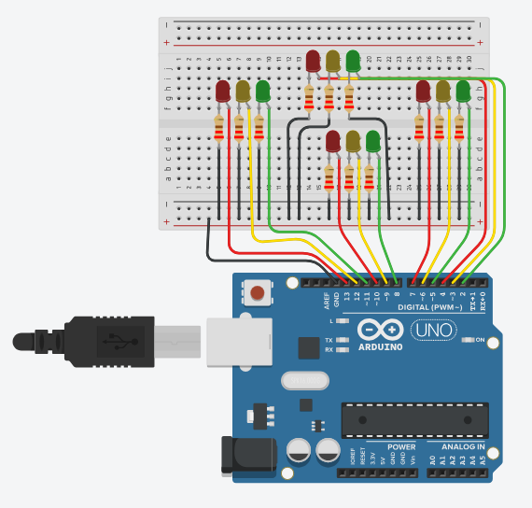

connections are made as per the circuit diagram.

Here’s a simple Arduino code to read the data from traffic sensor and to glow the LED .

int red_1=13;  
int orange_1=12;  
int green_1=11;  
int red_2=10;  
int orange_2=9;  
int green_2=8;  
int red_3=7;  
int orange_3=6;  
int green_3=5;  
int red_4=4;  
int orange_4=3;  
int green_4=2;  
  
void direction_1_green(void)  
{  
    digitalWrite(red_1,LOW);  
    digitalWrite(orange_1,LOW);  
    digitalWrite(green_1,HIGH);  
    digitalWrite(red_2,HIGH);  
    digitalWrite(orange_2,LOW);  
    digitalWrite(green_2,LOW);  
    digitalWrite(red_3,HIGH);  
    digitalWrite(orange_3,LOW);  
    digitalWrite(green_3,LOW);  
    digitalWrite(red_4,HIGH);  
    digitalWrite(orange_4,LOW);  
    digitalWrite(green_4,LOW); }  
  
void direction_2_orange(void)  
{  
    digitalWrite(red_1,HIGH);  
    digitalWrite(orange_1,LOW);  
    digitalWrite(green_1,LOW);  
    digitalWrite(red_2,LOW);  
    digitalWrite(orange_2,HIGH);  
    digitalWrite(green_2,LOW);  
    digitalWrite(red_3,HIGH);  
    digitalWrite(orange_3,LOW);  
    digitalWrite(green_3,LOW);  
    digitalWrite(red_4,HIGH);  
    digitalWrite(orange_4,LOW);  
    digitalWrite(green_4,LOW);  
     
}  
  
void direction_2_green(void)  
{  
    digitalWrite(red_1,HIGH);  
    digitalWrite(orange_1,LOW);  
    digitalWrite(green_1,LOW);  
    digitalWrite(red_2,LOW);  
    digitalWrite(orange_2,LOW);  
    digital Write(green_2,HIGH);  
    digitalWrite(red_3,HIGH);  
    digitalWrite(orange_3,LOW);  
    digitalWrite(green_3,LOW);  
    digitalWrite(red_4,HIGH);  
    digitalWrite(orange_4,LOW);  
    digitalWrite(green_4,LOW);  
     
}  
  
void direction_3_orange(void)  
  
{  
    digitalWrite(red_1,HIGH);  
    digitalWrite(orange_1,LOW);  
    digitalWrite(green_1,LOW);  
    digitalWrite(red_2,HIGH);  
    digitalWrite(orange_2,LOW);  
    digitalWrite(green_2,LOW);  
    digitalWrite(red_3,LOW);  
    digitalWrite(orange_3,HIGH);  
    digitalWrite(green_3,LOW);  
    digitalWrite(red_4,HIGH);  
    digitalWrite(orange_4,LOW);  
    digitalWrite(green_4,LOW);  
    }  
  
void direction_3_green(void)  
{  
    digitalWrite(red_1,HIGH);  
    digitalWrite(orange_1,LOW);  
    digitalWrite(green_1,LOW);  
    digitalWrite(red_2,HIGH);  
    digitalWrite(orange_2,LOW);  
    digitalWrite(green_2,LOW);  
    digitalWrite(red_3,LOW);  
    digitalWrite(orange_3,LOW);  
    digitalWrite(green_3,HIGH);  
    digitalWrite(red_4,HIGH);  
    digitalWrite(orange_4,LOW);  
    digitalWrite(green_4,LOW);  
    }  
    void direction_4_orange(void)  
{  
    digitalWrite(red_1,HIGH);  
    digitalWrite(orange_1,LOW);  
    digitalWrite(green_1,LOW);  
    digitalWrite(red_2,HIGH);  
    digitalWrite(orange_2,LOW);  
    digitalWrite(green_2,LOW);  
    digitalWrite(red_3,HIGH);  
    digitalWrite(orange_3,LOW);  
    digitalWrite(green_3,LOW);  
    digitalWrite(red_4,LOW);  
    digitalWrite(orange_4,HIGH);  
    digitalWrite(green_4,LOW);  
    }  
    void direction_4_green(void)  
    //green LED of direction 4 will turn ON  
{  
     digitalWrite(red_1,HIGH);  
     digitalWrite(orange_1,LOW);  
     digitalWrite(green_1,LOW);  
     digitalWrite(red_2,HIGH);  
     digitalWrite(orange_2,LOW);  
     digitalWrite(green_2,LOW);  
     digitalWrite(red_3,HIGH);  
     digitalWrite(orange_3,LOW);  
     digitalWrite(green_3,LOW);  
     digitalWrite(red_4,LOW);  
     digitalWrite(orange_4,LOW);  
     digitalWrite(green_4,HIGH);  
     }  
     void direction_1_orange(void)  
     //orange LED of direction 1 will turn ON  
     {  
         
         digitalWrite(red_1,LOW);  
          
        digitalWrite(orange_1,HIGH);  
        digitalWrite(green_1,LOW);  
        digitalWrite(red_2,HIGH);  
        digitalWrite(orange_2,LOW);  
        digitalWrite(green_2,LOW);  
        digitalWrite(red_3,HIGH);  
        digitalWrite(orange_3,LOW);  
        digitalWrite(green_3,LOW);  
        digitalWrite(red_4,HIGH);  
        digitalWrite(orange_4,LOW);  
        digitalWrite(green_4,LOW); }  
        void setup()  
        {  
            // Declaring all the LED's as output  
  
for(int I=2;i<=13;i++)  
pinMode(I, OUTPUT);  
  
} void loop()  
//In the loop function, we controlled the signal one // by one to control the flow of traffic.  
{  
    direction_1_green();  
    delay([5000](tel:5000));  
    direction_2_orange(); delay([3000](tel:3000));  
    direction_2_green(); delay([5000](tel:5000));  
    direction_3_orange(); delay([3000](tel:3000));  
    direction_3_green(); delay([5000](tel:5000));  
    direction_4_orange(); delay([3000](tel:3000));  
    direction_4_green(); delay([5000](tel:5000));  
    direction_1_orange(); delay([3000](tel:3000)); }

**UPLOAD THE CODE TO YOUR ARDUINO UNO:**

1. Open the ARDUINO IDE on your computer.
2. connect your Arduino UNO to your computer via USB.
3. Select the correct board and plot under the “tools “menu.
4. copy and paste the above code into the Arduino IDE.
5. click the “upload” button to upload the code to your Arduino Uno.
6. simulate the code to get the output.